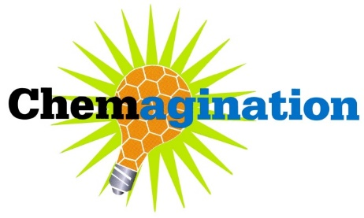
NYACS Chemagination 2026 - Intent to Participate Form

Please print or type requested information and return this form before February 9th, 2026

School Contact/
Advisor Name: Title:

E-mail address: Home Phone (optional): ( ) –

School Name:

School Address: Street

City State Zip code

Preferred mailing address if different from school address:

School Phone: ( ) – School Fax: ( ) –

Is the e-mail address written above the best way to reach you with important information? (Check one)

Yes No If no, please suggest an alternative:

If we need to call, what are the best times to reach you?

Which categories does your school intend to enter? (Please indicate the number of entries from each category)

Alternative Energy Sources Medicine/ Healthcare

Environment New Materials

To aid our planning, please indicate the total number of students and total number of teams:

Total number of teams ___ Total number of students

By submitting this form, I am committing my school/students to entering the Chemagination contest.
I will: notify Dr. Chavez and Dr. Wang immediately if there is any change in the status of our participation or our entries.

Signature: Date:

Send this form by email to:
Dr. Carlos Sanhueza Chavez, email: chavezc@stjohns.edu

Questions? Call Dr. Carlos Sanhueza Chavez at 718-990-7326 or E-mail: chavezc@stjohns.edu
Dr. Shanzhi Wang at 718-990-3135 or E-mail: wangs1@stjohns.edu

